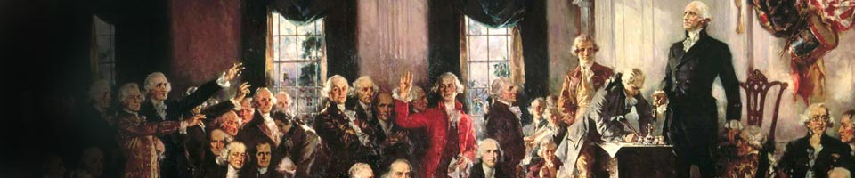
“A DEMOCRACY CAN NEVER BE IGNORANT AND FREE.” -Thomas Jefferson
Informational Meeting - You Are Invited
Middendorf-Kredell Branch Library, 2750 Hwy K, O’Fallon, MO
If you and I do not educate ourselves about our history, our Constitution and our government, we will not be prepared to self-govern. “We, the People” will not be prepared to guide the ship of state as was intended by our form of government and we will lose it all.
2015 | OCTOBER |  |  | Tuesday  20th  7:00
Sunday | Monday | Tuesday | Wednesday | Thursday | Friday | Saturday
27 | 28 | 29 | 30 | 01 | 02 | 03
04 | 05 | 06 | 07 | 08 | 09 | 10
11 | 12 | 13 | 14 | 15 | 16 | 17
18 | 19 | 20 | 21 | 22 | 23 | 24
25 | 26 | 27 | 28 | 29 | 30 | 31
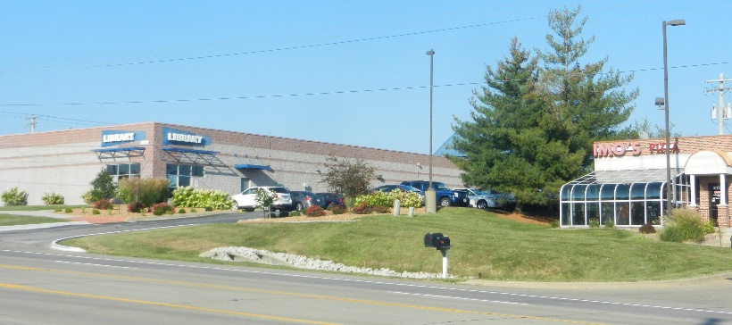
Earn it, Learn it or Lose it. Such a simple concept with such high stakes. Shall we defeat ignorance or be driven by it? ELL Constitution Clubs challenges you to do your part to earn your freedom. Take the ELL journey. Tad Armstrong, September, 2010
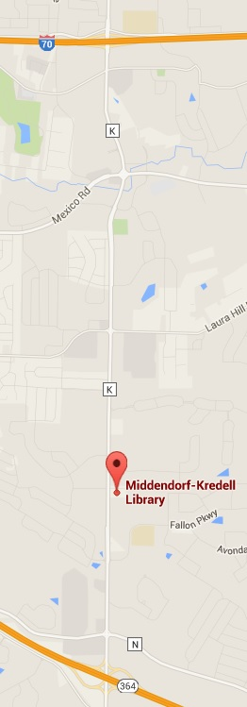
Hwy K
Between I-70 and 364
Next to Imo’s

2-1/2 miles south from I-70

1 mile north of 364
- Meets one evening a month
- Pre-reading materials handed out for next meeting
- Questions encouraged, Dialogue welcomed

Leader, Tad Armstrong is an Edwardsville, IL attorney, author and lecturer.
www.ellconstitutionclubs.com for more information

